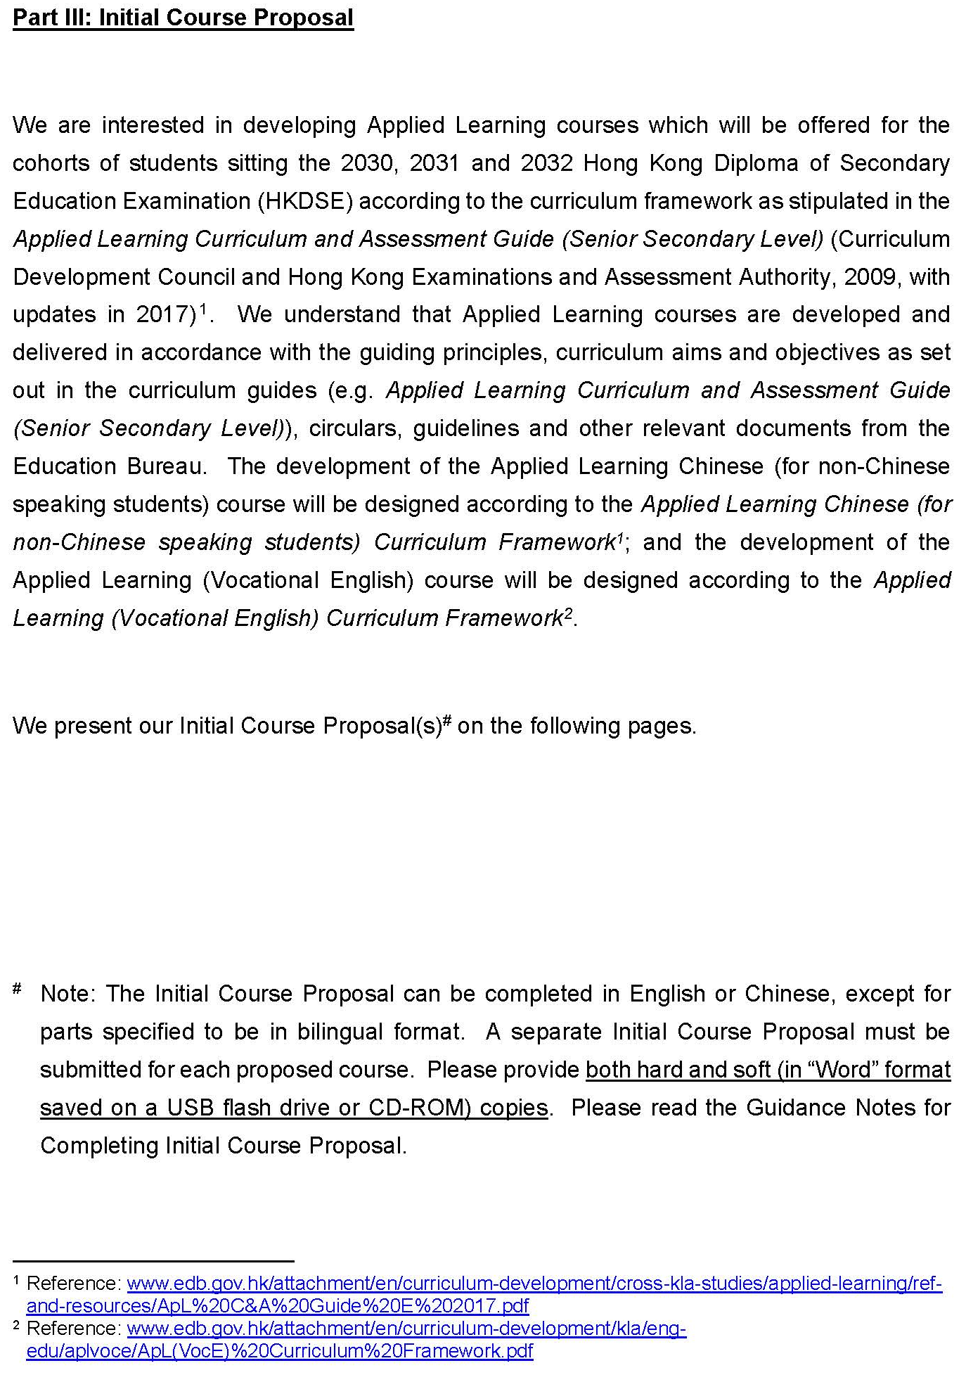
Applied Learning
應用學習
Initial Course Proposal 初步課程建議書
- Curriculum 課程

- Course particulars  課程基本資料 | Course title:  課程名稱 | Click or tap here to enter text.
- Course particulars  課程基本資料 | Institution:  機構 | Click or tap here to enter text.
- Course particulars  課程基本資料 | Area of studies:  學習範疇 | Choose an item.
- Course particulars  課程基本資料 | Medium of instruction:  教學語言 | Click or tap here to enter text.

- Aims  目標 | Click or tap here to enter text.
- Course synopsis  課程摘要 | Please complete both English and Chinese versions of template A3 (except for Applied Learning (Vocational English) and Creative English, for which only the English version is required.
- Links with professional and vocational fields  與專業和職業領域的連繫 | Click or tap here to enter text.
- Rationale for proposing the course and situation analysis  建議課程的理念和形勢分析 | Click or tap here to enter text.

- Institution 機構

- Capacity of institution  機構的能力 | Click or tap here to enter text.
- Track record  過往經驗 | Click or tap here to enter text.
- Internal quality assurance mechanism  內部質素保證機制 | Click or tap here to enter text.
- Contact information  聯絡資料 | Click or tap here to enter text.

- Implementation 施行

- Costing model  課程費用 | Please complete template C1.

Template A3

Applied Learning

Course Synopsis

Item | Description
- Course Title | Click or tap here to enter text.
- Course Provider | Click or tap here to enter text.
- Area of Studies/ Course Cluster | Choose Area of Studies./  Choose course cluster.
- Medium of Instruction | Click or tap here to enter text.
- Learning Outcomes | Upon completion of the course, students should be able to:  - …  - …  - …  - …  - …  - enhance self-understanding and explore directions on further studies and career pursuits.

Template A3
- Curriculum Map – Organisation and Structure
Core
Elective II
Elective III
Elective I

Template A3
- The Context
- The information on possible further study and career pathways is provided to enhance students’ understanding of the wider context of the specific Applied Learning course.
- The recognition of Applied Learning courses for admission to further studies and career opportunities is at the discretion of relevant institutions. Students who have successfully completed Applied Learning courses have to meet other entry requirements as specified by the institutions.

Possible further study and career pathways

Further studies
- …
- …
- …

Career development
- …
- …
- …

Complementarity with core subjects and other elective subjects  Enhancing and enriching, e.g.  - …  - …  - …  Expanding horizons, e.g.  - …  - …  - … |  |  |  |  | Relations with other Areas of Studies/  courses of Applied Learning  e.g.  - …  - …  - …
 |  |  | Course Title
Foundation knowledge developed in junior secondary education

The course is built upon the foundation knowledge students acquired in, e.g.
- …
- …
- …

Template A3
應用學習

課程摘要

項目 | 內容
1. 課程名稱 | 請按此輸入。
2. 課程提供機構 | 請按此輸入。
3. 學習範疇／課程組別 | 請選擇學習範疇。／  請選擇課程組別。
4. 教學語言 | 請按此輸入。
5. 學習成果 | 完成本課程後，學生應能：  - …  - …  - …  - …  - …  - 加深自我認識，探索升學及職業發展方向。

Template A3

6. 課程圖 – 組織與結構

必修部分
選修部分（二）
選修部分（三）
選修部分（一）

Template A3

7. 情境
- 升學及職業發展路向資訊有助提升學生了解應用學習課程相關行業及發展機會。
- 應用學習課程在升學及就業的資歷認可，由個別院校及機構自行決定。成功完成應用學習課程的學生仍須符合有關機構的入學或入職要求。

升學及職業發展路向

升學
- …
- …

職業發展
- …
- …

與核心科目及其他選修科目互相配合  提升及增益，例如：  - …  - …  - …  開拓空間，例如：  - …  - …  - … |  |  |  |  | 與應用學習其他學習範疇／  課程的關係  例如：  - …  - …  - …
 |  |  | 課程名稱
在初中教育發展的基礎知識

本課程建基於學生在下列學習領域所獲得的基礎知識，例如︰
- …
- …

Template C1
Applied Learning
Initial Course Proposal
(2030, 2031 and 2032 HKDSE)

Proposed Course Fee of Applied Learning Course

Course title :
Course provider/institution :
Course fee per student : | HK$
Class size (no. of students) : | Min.:[ |  | ] Max.: [ |  |  |  | ]
Maximum capacity (no. of students) : | 1st cohort: [ ] |  |  | 2nd cohort: [ ] |  | 3rd cohort: [ ]

Change in Course Fee and Justifications (if applicable)
Proposed course fee per student (a) | HK$
Existing course fee per student (if applicable) (b) | HK$
% change (if applicable) (c) = [(a) – (b)] / (b) x 100%  (Please round up to 1 decimal place) | %
Please provide justifications for the above change:

